1.4 Assignment: Building out and Validating Your Use Case using AI Agents
Mohammed Amer
IWU
3FA2026 AI Integration Capstone
SEPT 05, 2026

Complete Six-Phase Project Documentation
Executive Summary
The fictitious U.S. building-operations business BrightGrid Facilities serves modest commercial assets including offices, retail, clinics, and mixed-use buildings. BrightGrid Energy Insights, a cloud-based AI application, analyzes electricity and building-sensor data to identify unusual consumption patterns, rank likely causes, and notify facility managers before an energy problem becomes costly or equipment-related (Ramachandran & Agrawal, 2025).
The practical issue is that smaller building operators get electric bills and building-management data but no energy analysts. Thus, the MVP detects an abnormality, explains why, and suggests a next step. During the MVP, human operators will make HVAC equipment selections.
Problem framing, technical solution, design and prototype, testing and assessment, deployment, and post-launch feedback/iteration comprise the six-phase lifecycle. React and TypeScript for the web interface, FastAPI/Python for the API, PostgreSQL for application metadata, AWS IoT Core and Amazon Timestream for time-series ingestion, S3 for historical storage, and scikit-learn and XGBoost for a Python anomaly-detection pipeline are recommended A four-to-five-person team may complete the MVP in 16 weeks. MVP targets 100 pilot users in 25–50 buildings, followed by phased development to 10,000. At least 90% detection accuracy, three false warnings per site per month, dashboard load speed below two seconds at the 95th percentile, 99.5% availability, and 80% pilot-user retention after 90 days will determine success (Ramachandran & Agrawal, 2025). The NIST AI Risk Management Framework will guide security, auditability, and responsible-AI practices throughout the lifespan.
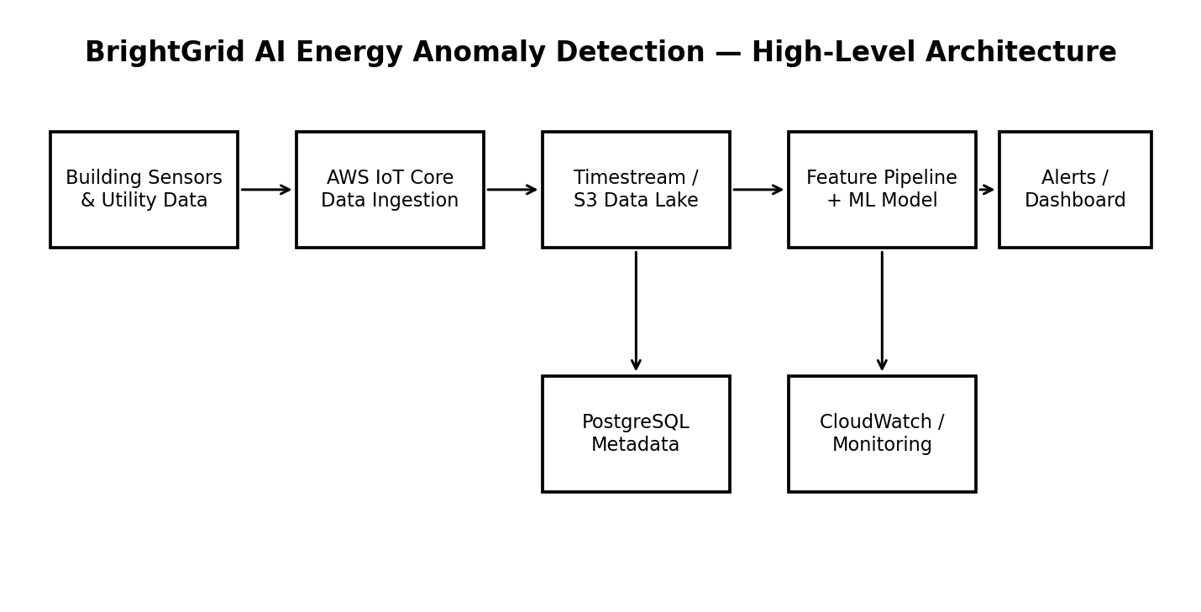
Figure 1. Proposed high-level technical architecture.

Phase 1 – Problem Framing
1.1 Company Background
BrightGrid Facilities is positioned as a 35-person facilities-technology firm that manages energy and maintenance services for small commercial property owners. The company wants to add a subscription software product rather than relying only on consulting revenue. The first product will target buildings with basic smart meters, utility exports, or building-management-system feeds (Ramachandran & Agrawal, 2025).
1.2 Specific Problem
Facility managers can see energy totals but frequently lack continuous, automated analysis. Abnormal consumption may remain hidden until the monthly utility bill arrives. Examples include HVAC schedules running after business hours, a failing sensor, a stuck damper, unexpected refrigeration load, or an unexplained week-over-week increase in electricity use.
1.3 Target Users and Personas
Persona | Role | Needs | Pain Points
Maya – Property Manager | Manages 10–30 buildings | Quick portfolio-level visibility; actionable alerts | Too many dashboards; limited technical staff
Carlos – Facility Technician | Investigates building issues | Clear anomaly evidence and likely causes | Manual troubleshooting; incomplete data
Priya – Operations Director | Owns operating costs | Portfolio trends, savings evidence, reports | Hard to prove ROI; inconsistent reporting

1.4 Success Criteria
Detect meaningful abnormal energy patterns with at least 90% precision during pilot evaluation.
Reduce time spent identifying a likely energy issue by at least 50% compared with the customer's current workflow.
Keep false alerts to three or fewer per building per month after model calibration.
Generate an understandable explanation and evidence for every high-priority alert.
Demonstrate a measurable reduction in avoidable energy consumption at pilot sites, with a target of 5–10% for buildings where actionable anomalies are found.
Maintain 99.5% or better service availability during production operation.
1.5 Market Size and Competitive Landscape
An academic planning model estimates the first serviceable market, not a third-party projection. The Data Explorer of EPA's ENERGY STAR Portfolio Manager ecosystem has over 150,000 U.S. commercial and multifamily buildings, representing a huge addressable population of benchmarking-ready facilities. About 25% of U.S. commercial building space is benchmarked in Portfolio Manager (Ramachandran & Agrawal, 2025). BrightGrid's cautious first market forecasts 5,000 small-to-mid-sized buildings might buy a $3,000 yearly software subscription, providing a $15 million ARR first viable potential.
Competitor Category | Strength | Gap BrightGrid Targets
Enterprise building-management platforms | Deep controls and integrations | Often expensive and complex for small operators
Utility dashboards | Reliable billing/usage visibility | Limited predictive/anomaly intelligence
Energy consultants | Human expertise and tailored recommendations | Expensive and not continuous
Generic BI tools | Flexible visualization | Require users to build their own analytical logic

1.6 Scope Boundaries
MVP analyzes energy and sensor data; it does not autonomously control HVAC or other equipment.
Initial deployment targets commercial buildings in the United States.
The first release supports electricity-focused anomaly detection; water, gas, and carbon optimization are later extensions (Ramachandran & Agrawal, 2025).
The system provides decision support and evidence, not engineering certification or guaranteed savings.

Phase 2 – Technical Solution
2.1 Proposed Technology Stack
Layer | Technology | Purpose
Frontend | React + TypeScript + Vite | Responsive dashboard and alert workflows
UI | Tailwind CSS + accessible component library | Consistent, responsive interface
Backend | Python + FastAPI | REST API, authentication, orchestration
Application DB | PostgreSQL | Users, organizations, buildings, alert states, audit metadata
Time-series data | Amazon Timestream | High-volume timestamped sensor/energy observations
Object storage | Amazon S3 | Raw files, training datasets, model artifacts
IoT ingestion | AWS IoT Core | Secure MQTT/device and gateway ingestion
ML | scikit-learn + XGBoost | Baseline anomaly detection and classification/ranking
Data processing | Python/Pandas + AWS Lambda/ECS jobs | Cleaning, feature engineering, scheduled processing
Cloud | AWS | Managed infrastructure, scaling, security, monitoring
Monitoring | Amazon CloudWatch | Logs, metrics, alarms, dashboards
CI/CD | GitHub Actions + AWS deployment pipeline | Automated test/build/deploy workflow(Ramachandran & Agrawal, 2025).

2.2 Architecture Decisions
A modular cloud architecture is better than a monolithic server since ingestion, analytics, and the web application scale differently. AWS IoT Core may transport device communications directly into Amazon Timestream and trigger Lambda operations using IoT rules to control device telemetry to time-series storage. React/TypeScript is chosen over server-rendered templates because the dashboard-heavy offering requires interactive filtering and near-real-time alert updates. FastAPI/Python is preferred over Node-only services because the ML pipeline is Python-native. PostgreSQL stores relational application data while Timestream manages time-series telemetry to avoid overloading the transactional database with analytical queries.
2.3 ML Approach
Data validation: remove duplicates, flag missing intervals, standardize units, and identify sensor dropouts.
Feature engineering: rolling mean, rolling standard deviation, hour-of-day, day-of-week, weather-adjusted load, recent trend, and building baseline features.
Baseline model: seasonal statistical thresholds provide an interpretable benchmark.
Primary model: Isolation Forest or related unsupervised method identifies unusual patterns when labeled anomalies are scarce (Ramachandran & Agrawal, 2025).
Supervised enhancement: XGBoost ranks likely anomaly categories after sufficient technician-labeled examples are collected.
Explanation layer: the alert shows the baseline comparison, magnitude of deviation, duration, and top contributing signals rather than presenting an unexplained model score.
2.4 Third-Party APIs and Integrations
Weather API: hourly temperature and weather observations for weather-normalized comparisons.
ENERGY STAR Portfolio Manager Web Services: optional benchmarking integration for customers that authorize data exchange; EPA provides RESTful web services for exchanging Portfolio Manager data.
Identity provider: managed OAuth 2.0/OpenID Connect service for authentication and enterprise SSO in later versions.
Optional building-management-system connector: vendor-specific API or gateway integration where supported (Ramachandran & Agrawal, 2025).
2.5 Integration Requirements
Sensor/gateway payloads must contain timestamp, building/site identifier, metric, value, and unit.
All device traffic must use TLS; device credentials are unique and revocable.
The ingestion layer must tolerate duplicate messages and short network interruptions.
APIs must support tenant isolation so one customer's building data cannot be accessed by another customer.
Every alert and model version must be traceable through an audit record (Ramachandran & Agrawal, 2025).

Phase 3 – Design & Prototype
3.1 MVP Feature List
Secure account creation and organization onboarding.
Building registration and data-source configuration.
Portfolio dashboard showing energy trend, building health, and active anomalies.
Alert center with severity, duration, deviation magnitude, and confidence.
Alert detail page showing baseline comparison and recommended investigation steps.
Historical trend charts with hourly/daily/weekly views.
Email notifications for high-severity anomalies.
Basic role-based access: administrator, manager, technician, read-only.
Audit trail for alert acknowledgement and status changes.
3.2 UI/UX Design Approach
The interface follows a 'detect → understand → act' pattern. The home screen answers three questions: Which buildings need attention? How serious is each issue? What should I investigate first? Visual emphasis is placed on trends and exceptions rather than decorative dashboards. Color is not the only status signal; icons, labels, severity text, and accessible contrast are used so users can interpret alerts without relying on color alone (Ramachandran & Agrawal, 2025).
3.3 Core Functionality That Must Work
Workflow | MVP Acceptance Condition
Connect data source | A valid sample feed reaches the platform and appears in the selected building.
Detect anomaly | Known test anomalies are detected within the target processing window.
Explain anomaly | Alert page displays baseline, deviation, time period, and contributing signals.
Acknowledge alert | User can assign status and record an investigation note.
Notify user | High-severity event produces an email notification within five minutes.
Tenant isolation | User cannot retrieve another organization's building data through UI or API.

3.4 Intentionally Excluded From MVP
Automatic equipment control or closed-loop HVAC optimization.
Native mobile applications.
Complex predictive maintenance for individual machine components.
Carbon-accounting automation across every utility type.
Multi-country localization and multilingual support.
Custom deep-learning models requiring large labeled datasets.
3.5 End-to-End User Flow
User signs up and verifies identity.
Organization administrator creates the organization and invites team members.
Administrator creates a building profile and selects the available data source.
System validates the incoming data and establishes an initial baseline over approximately 14 days.
Dashboard begins displaying normal patterns and anomaly scores.
A high-priority anomaly is detected and the facility manager receives an email alert.
Manager opens the alert, reviews evidence, and assigns it to a technician.
Technician records an investigation outcome.
Outcome is retained as feedback for future model calibration.
3.6 Initial Technical Limitations
The first model may produce false positives during holidays, occupancy changes, or sensor failures.
Buildings without adequate historical data will have weaker baselines.
The MVP depends on data quality and cannot compensate for consistently broken sensors.
Weather normalization will be imperfect when weather data is coarse or geographically distant.
Model performance will vary by building type until enough labeled outcomes are collected.

Phase 4 – Testing & Evaluation
4.1 KPI and Performance Targets
Metric | Target | Measurement Method
Anomaly precision | ≥90% | Technician-reviewed sample of flagged events
False alerts | ≤3/site/month | Production alert log normalized by active building
Detection latency | ≤5 minutes | Event timestamp to alert creation
Dashboard load | <2 seconds p95 | Browser performance monitoring under 100 concurrent users
API latency | <500 ms p95 | Synthetic API tests excluding long-running analytics
Availability | ≥99.5% monthly | CloudWatch uptime and synthetic health checks
Pilot retention | ≥80% at 90 days | Active organizations/users divided by enrolled cohort

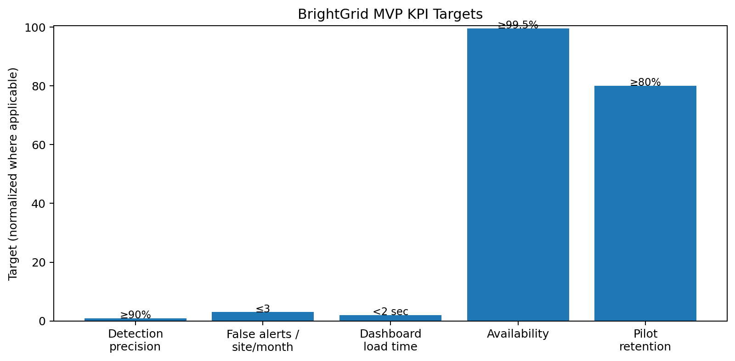
Figure 2. Selected MVP KPI targets.
4.2 Testing Methodology
Unit testing: target at least 80% backend test coverage for business-critical services.
Data-quality testing: inject missing, duplicated, delayed, and out-of-range observations and confirm correct handling.
Model testing: maintain a frozen evaluation dataset containing normal periods and technician-labeled anomalies.
Integration testing: validate ingestion → storage → feature pipeline → model → API → notification.
Security testing: authentication, authorization, tenant isolation, dependency scanning, API abuse testing, and secrets-management checks.
Load testing: simulate 100 active users first, then 1,000 and 10,000-user production profiles before each scaling milestone.
4.3 Model Evaluation
Accuracy alone is not sufficient because anomalous events are relatively rare. Precision, recall, false-alert rate, detection latency, and business impact will be tracked. A model will not be promoted solely because its offline score improves; the team must verify that users can interpret and act on its alerts (Ramachandran & Agrawal, 2025).
4.4 A/B Testing Plan
Test A: generic alert text versus evidence-rich alerts containing baseline comparison and top contributing signals.
Primary outcome: acknowledgement-to-action rate within 24 hours.
Secondary outcomes: time to first investigation, dismissal rate, and user satisfaction.
Run the experiment for at least four weeks with randomized eligible users and a minimum sample size determined before launch.
Do not A/B test safety-critical automatic controls because the MVP does not perform autonomous equipment actions.
4.5 Validation That the Product Solves the Problem
The strongest validation is operational rather than cosmetic. For each pilot building, the team will establish a baseline for energy use and time-to-diagnosis. The pilot will compare pre-product and post-product workflows, document confirmed anomalies, and estimate avoided waste only where evidence supports the estimate. Interviews will test whether users trust the alerts enough to change behavior.

Phase 5 – Deployment
5.1 Deployment Strategy
BrightGrid will deploy to AWS using managed services and infrastructure-as-code. The web frontend will be served through a CDN/static hosting layer, the FastAPI service will run in containers, and asynchronous jobs will run through managed compute. Database and time-series services remain managed to reduce operational burden for the small engineering team.
5.2 Scaling Plan: 100 to 10,000 Users
Stage | Expected Users | Architecture Focus | Exit Condition
Pilot | 100 | Single production environment; conservative resource sizing | Stable pilot with ≥90% precision
Early production | 1,000 | Horizontal API scaling; queue-based processing; database indexes | SLOs met for 30 days
Growth | 5,000 | Read replicas/caching where needed; partitioned analytics jobs | Load test passes 2× peak
Scale | 10,000 | Autoscaling, workload isolation, stronger observability, disaster-recovery rehearsal | SLOs and recovery targets met

5.3 Security and Compliance
TLS in transit and encryption at rest using AWS-managed encryption services.
Least-privilege IAM roles and separate development, staging, and production accounts/environments.
Tenant isolation enforced at API and database query layers.
Secrets stored in AWS Secrets Manager rather than source code.
Audit logging for administrative actions, data-source changes, alert status changes, and model deployment.
Automated dependency and container vulnerability scanning.
Regular backups with tested restoration procedures.
Privacy policy and data-retention schedule defining what telemetry is retained and for how long.
NIST AI RMF will guide governance of validity/reliability, safety, security/resilience, accountability/transparency, and privacy-enhanced practices. NIST describes the AI RMF as a voluntary framework for managing AI risks across design, development, deployment, and use.
The product is not intended to process health records or payment-card data in the MVP; if future integrations introduce regulated data, the compliance scope will be reassessed before implementation.
5.4 Monitoring and Alerting
Infrastructure metrics: CPU, memory, container restarts, database connections, queue depth.
Application metrics: API error rate, p95 latency, authentication failures, ingestion failures.
ML metrics: anomaly rate by building, alert volume, precision from reviewed events, model drift indicators.
Business metrics: active buildings, acknowledged alerts, investigation completion, retention.
Pager/incident alerts triggered for availability below SLO, sustained error rates, ingestion outages, or suspicious authentication patterns.
5.5 Phased Rollout
Internal alpha: 2–3 buildings; engineering and product staff validate the complete workflow.
Design-partner beta: 10 buildings; weekly review of false positives and usability (Feng & Xu, 2025).
Controlled production: 25–50 buildings; monitored expansion with rollback capability.
General availability: broader customer onboarding after KPI and security gates are passed.
Post-GA optimization: scale infrastructure and refine models based on real-world outcomes.
Phase 6 – User Feedback & Iteration
6.1 Feedback Collection
In-product one-click alert feedback: useful / not useful / wrong reason.
Quarterly customer interviews with property managers and technicians.
Support-ticket categorization to identify recurring problems.
Product analytics covering alert views, acknowledgements, dismissals, investigation completion, and retention.
Monthly customer advisory sessions with a small group of design partners.
Model feedback labels created when technicians confirm or reject an alert.
6.2 Priority Features for Version 2
Priority | Feature | Reason
P0 | Better anomaly explanations and alert grouping | Reduce alert fatigue and improve trust
P0 | Technician feedback loop for model retraining | Convert user outcomes into labeled data
P1 | Utility-bill and Portfolio Manager integration | Lower onboarding effort and improve benchmarking
P1 | Building-level savings reports | Demonstrate financial value to decision makers
P2 | Mobile-responsive alert actions | Support technicians away from desks
P2 | Additional utilities and carbon metrics | Expand value beyond electricity

6.3 Three-Month Iteration Timeline
Month | Activities | Primary Deliverables
Month 1 | Collect feedback; tune thresholds; remove top false-positive patterns | Model v1.1; alert UX improvements
Month 2 | Run experiments; improve integrations; refine reporting | A/B test results; integration beta
Month 3 | Validate retention and ROI; prioritize roadmap | v2 backlog; customer value report; release plan

6.4 Post-Launch Success Metrics
≥80% 90-day customer retention.
≥60% of high-priority alerts acknowledged within 24 hours.
≥50% reduction in time-to-diagnosis for confirmed pilot issues.
≥90% precision for high-priority anomaly alerts (Feng & Xu, 2025).
≥5% measurable energy reduction in a subset of eligible pilot buildings where actionable issues are confirmed.
Net product satisfaction of at least 4.0/5 among active pilot users.
6.5 One-Year Roadmap
Quarter | Major Milestones
Q1 | MVP launch; 25–50 buildings; establish data-quality and model-monitoring baseline
Q2 | v2 alert explanations; feedback-driven retraining; Portfolio Manager integration beta
Q3 | Multi-utility analytics; savings reports; expanded connector library; 5,000-user scalability validation
Q4 | Enterprise controls, stronger SSO, regional expansion planning, 10,000-user readiness and annual model-risk review

Implementation Plan and Governance
7.1 16-Week Delivery Schedule
Weeks | Workstream | Key Outputs
1–2 | Discovery & data design | Requirements, data contracts, UX wireframes, risk register
3–5 | Platform foundation | AWS environments, auth, PostgreSQL, ingestion prototype
6–8 | ML baseline | Data pipeline, baseline model, evaluation dataset
9–11 | Product MVP | Dashboard, alert center, explanations, notifications
12–13 | Integration & security | End-to-end tests, security tests, monitoring
14–15 | Pilot | 2–3 internal buildings, tuning, defect resolution
16 | Go/no-go | KPI review, stakeholder sign-off, controlled beta plan

7.2 Team Roles
Role | Estimated Allocation | Responsibilities
Product manager / business analyst | 0.75 FTE | Scope, personas, requirements, stakeholder decisions
Full-stack engineer | 1.0 FTE | React frontend, FastAPI backend, integrations
ML/data engineer | 1.0 FTE | Data pipeline, features, models, evaluation
Cloud/security engineer | 0.5 FTE | AWS, IAM, CI/CD, monitoring, security
UX designer / QA | 0.5 FTE | Prototype, usability testing, test planning

7.3 Key Project Risks
Risk | Likelihood | Impact | Mitigation
Poor sensor/data quality | High | High | Validation rules, data-quality score, onboarding checks
False-positive alert fatigue | Medium | High | Threshold tuning, alert grouping, user feedback
Insufficient labeled anomalies | High | Medium | Unsupervised baseline plus technician labeling
Cloud cost growth | Medium | Medium | Budgets, usage alarms, right-sizing, lifecycle policies
Unauthorized tenant access | Low | Critical | Defense-in-depth authorization and security testing
Customer does not act on alerts | Medium | High | Evidence-rich alerts, workflow tracking, interviews

7.4 Stakeholder Decision Gates
Gate 1 – Problem/market approval: sponsor confirms target customer and measurable problem.
Gate 2 – Architecture approval: engineering and security approve stack and data flows.
Gate 3 – MVP readiness: product owner approves core workflows and acceptance tests.
Gate 4 – Pilot readiness: security, QA, and model-evaluation thresholds are met.
Gate 5 – General availability: product meets KPI, reliability, support, and governance requirements.

Appendix A – AI Prompts Used
The following prompts were used as part of the AI-assisted documentation workflow. AI-generated content was reviewed and refined for feasibility, consistency, and academic requirements.
1. Generate 3 different AI/ML web application use cases for me to choose from. Make them diverse and interesting. For each option provide company name, industry/sector, problem, AI/ML solution, and why it would be valuable. Include at least one RAG-based application and make the ideas realistic for a small team (Feng & Xu, 2025).
2. I'm building BrightGrid Facilities, a fictional facilities-technology company, and BrightGrid Energy Insights, an AI-powered web application that detects unusual energy consumption in small commercial buildings and explains likely causes. Generate comprehensive documentation for all 6 phases of the AI/Tech Project Lifecycle, including specific technical technologies, metrics, timelines, and deployment details (Feng & Xu, 2025).
3. Refine Phase 1 so the business problem, personas, market assumptions, competitive landscape, and measurable success criteria are realistic for a small B2B SaaS company.
4. Refine Phase 2 into a technically credible architecture using AWS, Python, React, PostgreSQL, time-series storage, and practical machine-learning libraries. Explain technology choices and alternatives.
5. Refine Phase 3 into an MVP specification with user flow, acceptance criteria, exclusions, and known technical limitations (Feng & Xu, 2025).
6. Refine Phase 4 with 5–7 measurable KPIs, realistic performance targets, model evaluation methods, load testing, and A/B testing.
7. Refine Phase 5 with a deployment strategy from 100 to 10,000 users, AWS services, security controls, monitoring, compliance considerations, and phased rollout.
8. Refine Phase 6 with feedback collection, a three-month iteration plan, v2 priorities, post-launch metrics, and a one-year roadmap.
9. Review the complete lifecycle for internal consistency. Identify unrealistic assumptions, duplicated requirements, missing risks, or metrics that cannot be measured, and propose corrections.
Appendix B – AI Acceleration Reflection
AI turned a wide project concept into a structured lifecycle plan using similar vocabulary across business, technical, testing, deployment, and iteration parts, speeding up documentation. AI generated candidate use cases, personas, design options, quantifiable KPIs, test scenarios, deployment phases, and roadmap suggestions instead of beginning from scratch. The fastest way to explore options and find information like model-drift monitoring, tenant isolation, alert fatigue, and explicit MVP exclusions was the most important advantage.
AI was used for planning, not authority. Technical claims were verified against reliable sources, assumptions like the original market size were labeled as estimations, and the final design was adjusted to fit a small crew. Because AI-generated requirements may be internally reasonable but operationally incorrect, the lifecycle utilizes human decision gates. This shows how AI may speed up documentation while needing human judgment, validation, and responsibility.

Appendix C – References
Feng, Y., & Xu, R. (2025). Advancing global sustainability: The role of the sharing economy, environmental patents, and energy efficiency in the Group of Seven’s path to sustainable development. Sustainability, 17(1), 322. https://www.mdpi.com/2071-1050/17/1/322
Malinovec Puček, M., Khoja, A., Bazzan, E., & Gyuris, P. (2023). A data structure for digital building logbooks: Achieving energy efficiency, sustainability, and smartness in buildings across the EU. Buildings, 13(4), 1082. https://www.mdpi.com/2075-5309/13/4/1082
National Institute of Standards and Technology. (2023). Artificial Intelligence Risk Management Framework (AI RMF 1.0).
National Institute of Standards and Technology. (2024). Artificial Intelligence Risk Management Framework: Generative Artificial Intelligence Profile.
Ramachandran, S., OV, G. S., & Agrawal, T. (2025, November). A Review of AWS IoT: Architecture, Applications, and Research Directions. In 2025 IEEE First International Conference on Innovations in Engineering and Next-Generation Technologies for Sustainability (ICINVENTS) (Vol. 1, pp. 1-6). IEEE. https://ieeexplore.ieee.org/abstract/document/11402221/
Soongpol, B., Netinant, P., & Rukhiran, M. (2024). Practical sustainable software development in architectural flexibility for energy efficiency using the extended agile framework. Sustainability, 16(13), 5738. https://www.mdpi.com/2071-1050/16/13/5738

